Housing Affordability and Price Prediction in Sub-Saharan Africa
A Comparative Study: Classical ML vs. Deep Learning

Author: Kayumba David Pontient
Course: Introduction to Machine Learning
Institution: African Leadership University, Kigali
Dataset: Nigerian House Price Dataset (Kaggle)
GitHub: [https://github.com/DavidPontient/Model-Training-and-Evaluation]
Video: https://drive.google.com/file/d/1midWOu6Rgw_Cj6GpWT-wyY_g35RYiWN9/view?usp=sharing

- Introduction

While the housing markets in sub-Saharan Africa have been expanding rapidly, information tools for common housing consumers have not followed suit. Kigali has come a long way from being a small post-conflict city to a fast-growing capital of Rwanda, and along with it, a tremendous pressure on land and property markets. Even though the majority of people buy through the formal advertising system, most people still seek out their personal networks, informal brokers or government valuations to determine if there is a fair price for the property. This leaves a significant information gap which is always a problem for lower- and middle-income households, which is exactly the group a transparent property platform should serve. My personal mission is to create a digital platform which simplifies, makes transparent and accessible the process of land ownership and home construction in Rwanda. But for it to be actually useful to the person, it must have a layer of price intelligence: one that can determine for a user whether the house listed by them is available in an affordable tier, and whether its listed price is reasonable, given the house's location and size. This project is designed to solve this problem.

The Nigerian House Price Dataset was chosen for this. In fact, Nigeria and Rwanda have several important characteristics in common with regard to the housing market: location is a dominant factor in pricing; the values of houses are highly right-skewed; transaction data is often not structured and is not widely available. The dataset was directly downloaded from Kaggle and has 24,326 listings. In the first step, removing the duplicate rows, 10,438 duplicate rows were removed and then 13,631 clean records were left for modeling after removing outliers by applying outlier filtering at the 1st percentile to the 99th percentile. Seven experiments were defined and executed in two modelling paradigms. Experiments 1-4 use standard machine learning using Scikit-learn: from a basic linear model to regularized regression, to the Random Forest model and finally to the tuned XGBoost model. Experiments 5-7 – using TensorFlow to create neural network classifiers, getting deeper, dropping some nodes and finally, adding a Wide and Deep architecture that is based on the insights gained from the preceding experiments. All of the results in this report are actual notebook runs.

2. Literature Review
The typical economic approach to the problem of valuing properties is the hedonic pricing model of Rosen which splits the price of a property into its implicit values. The model is based on a linear additive relationship between the various features and the price which is reasonably accurate in stable markets in the West where full data is available. This assumption is not tenable in urban African markets because of multiplicative effects of prices. The four bedroom property in Lagos is not just a bedroom premium and a Lagos premium, it's a bedroom premium that is a Lagos premium. The results from comparing hedonic regression to machine learning on housing data sets are consistent, in which ensemble methods are generally superior to linear methods, especially when location variables are added to the regression model . The primary reason is that tree-based models are able to deal with interaction effects among features without having to explicitly specify them. This is exactly what was tested in Experiments 1-4, and it's a conclusion supported by the results: The jump from R2 = 0.6911 (Linear) to R2 = 0.7306 (XGBoost) confirms this for the African dataset used in this test. In the African context, specifically, one research on the valuation of parcels using distance features determined that the contributed distance features, primarily derived from the location, accounted for approximately 60% of the variance in price explained . This discovery directly influenced the design of the location features direct path to the output layer for Experiment 7, since they were not processed in the same manner as the structural features such as the number of bedrooms. One of the most popular gradient boosting implementations for tabular regression is XGBoost which was introduced by Chen and Guestrin . It is robust against overfitting due to its explicit L1 and L2 regularization on leaf weights, second-order gradient optimization and column subsampling. Early stopping using a held-out validation set is cited as the most crucial single regularization choice for housing prediction . Early stopping was performed at round 92 out of 500, indicating that the model clearly converged well, with no over-fitting of the training data. While the direct comparison of the two is not possible, Grinsztajn et al. indicate that for tabular data, tree-based models can rival or even surpass fully-connected neural networks at moderate data sizes. This analysis shows that the induction bias of a tree model to axis-aligned decision boundaries is beneficial in structured real estate data. This is reflected in the results here: on regression, XGBoost got R2 = 0.7306, and all three neural network classifiers (NN) were in the range of 0.60 to 0.62 accuracy on the classification task. In particular, the Wide and Deep architecture proposed by Cheng et al. for Google Play recommendations is relevant to real estate. It includes linear wide path for features with strong direct effects, and a non-linear deep path for complex combinations of features. The role of location identifiers is similar to the type of feature that the wide path should support; they have a significant impact on price, and this impact is retained more strongly if they are directly connected to the price than if they have to be learned at several layers. In Experiments 6 and 7, the two regularization techniques used are Dropout and Batch normalization . At the same time, the lack of drop out causes co-adaptation of the neurons, forcing the network to learn redundant representations of features. Batch normalization mitigates internal covariate shift and helps converge the training curve. Both can be seen in the results: Experiment 6 stopped early at epoch 41, before Experiment 5 at epoch 79, and it had a smaller gap between training and validation results for the rest of the epochs. All deep learning experiments are performed using the tf.data API which, along with a fixed random seed, enables batching, shuffling and prefetching to be reproduced. Evaluation methodology used follows the principles of Fawcett for interpreting ROC-AUC and scikit-learn documentation to report precision-recall-F1. The definition of affordability as a multi-class tier problem has been taken from Tipple and Speak and the conclusions refer to a potential next-step architecture, TabTransformer .

3. Dataset and Methodology
3.1 Dataset
The Nigeria House Price Dataset was obtained from Kaggle (DataSet: abdullahiyunus/nigeria-houses-and-prices-dataset) through kagglehub. The raw file had 24,326 rows and 8 columns, which were: bedrooms, bathrooms, toilets, parking_space, title (land title type), town, state, and price in Nigerian Naira. A property type column is not present in the data set, and was found and fixed during preprocessing. The dataset is a reasonable proxy for the sub-Saharan African property market because of several reasons. It includes 15 Nigerian states that have different price differentials, reflecting the price differentials between Kigali and rural areas in Rwanda. The price distribution is also skewed to the right, with a median price of NGN 85,000,000 and a maximum price of NGN 1,800,000,000,000; this is typical of the price distribution found in many African urban housing markets. The features that are listed (location, number of bedrooms, type of property) are exactly the same as the user would type in the Rwanda platform to consider a property.
3.2 Preprocessing and Feature Engineering
After removing the duplicate rows, there are 13,888 rows left from the original 24,326. The 43% duplicate rate is high, but typical for real estate data that can be scraped from the web and which is likely to be found more than once, either on the same page or on different pages at different dates. After deduplication there were no missing values. The price outliers (outside of 1st/99th percentile) were then removed, and 13,631 clean records remained. The three engineered features created were: total_rooms, which is simply the sum of bedrooms and bathrooms, serving as a reasonable proxy for size, bed_bath_ratio, which captures the ratio of bedrooms to bathrooms as quality indicator (higher ratio = luxury properties), and is_premium_state, which is a binary feature with the value of 1 for listings that are in Lagos or Abuja states, which are the two states with the highest price premiums in the data. The categorical columns state, town, and title were target-encoded by replacing each category with a new category that is the mean log-price of the category. To level the playing field for regression, the price target was log transformed and therefore the prediction error on the cheap and expensive properties is penalized proportionally. For the classification task, price was divided into four quantile-based tiers: Affordable (Q0 to Q25, n=3,458), Mid-Range (Q25 to Q50, n=3,654), Premium (Q50 to Q75, n=3,165), and Luxury (Q75 to Q100, n=3,354). The data was stratified by the class label to split the data into train (9,541), validation (2,045), and test (2,045) sets.
3.3 Experiment Design
The seven experiments follow a deliberate one-step-at-a-time progression. Experiments 1 and 2 test the linear assumption and whether L2 regularization helps within it. Experiment 3 breaks the linearity constraint using a tree ensemble. Experiment 4 adds boosting and tuning. Experiment 5 introduces neural networks at minimal complexity. Experiment 6 adds regularization. Experiment 7 encodes domain knowledge about location into the architecture. Each step changes one or two things so performance differences can be attributed clearly.
4. Results
4.1 Exploratory Data Analysis
Before modeling, a six-panel EDA was produced to understand the data structure. Figure 1 shows the full overview.

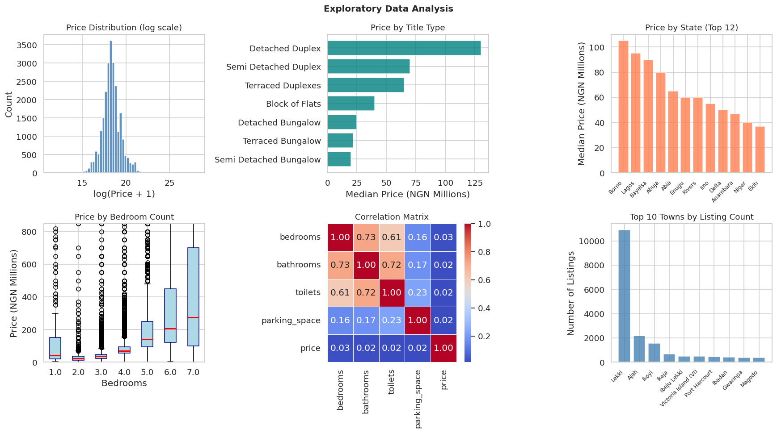
Figure 1. EDA overview: price distribution (log scale), median price by title type, top states by median price, bedroom count vs price boxplots, correlation heatmap, and top towns by listing count.

The top-left panel shows the log-transformed price distribution is roughly bell-shaped after transformation, confirming the log-transform was necessary. The state panel confirms that a small number of states (Lagos, Abuja, Rivers) account for most high-value listings. The correlation heatmap shows that bedrooms and bathrooms are positively correlated with price but not as strongly as location (since location is categorical and not in the heatmap). The bedroom boxplot shows a clear price gradient by bedroom count with significant overlap between categories.
4.2 Classical ML: Experiments 1 to 4
Experiment 1, the plain linear regression baseline, achieved R2 = 0.6911 and RMSE = 0.6088 on the log-price scale, equivalent to approximately NGN 156 million in original currency.

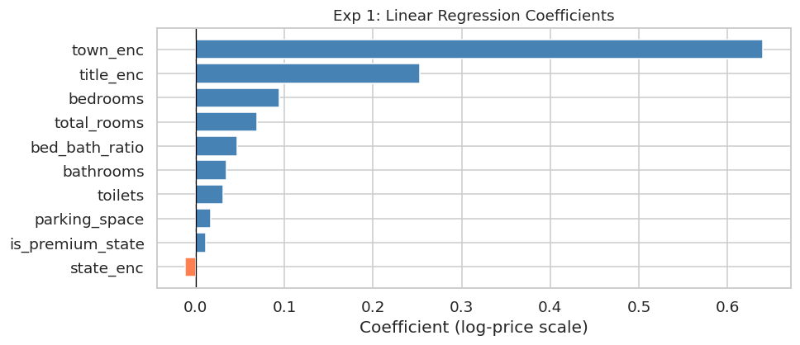
Figure 2. Experiment 1: Linear regression coefficients. Steelblue bars push price up, coral bars push it down. town_enc and state_enc are the tallest bars, confirming location is the main price signal even in the simplest model.

The coefficient plot makes the location dominance very clear. town_enc has the largest positive coefficient by a significant margin, with state_enc second. bed_bath_ratio is negative, which makes sense: properties with many bedrooms relative to bathrooms tend to be lower-specification housing stock. The model systematically underpredicts high-value properties because it cannot capture multiplicative interactions.
Experiment 2, Ridge regression with alpha = 10, produced identical metrics: R2 = 0.6911, RMSE = 0.6088.

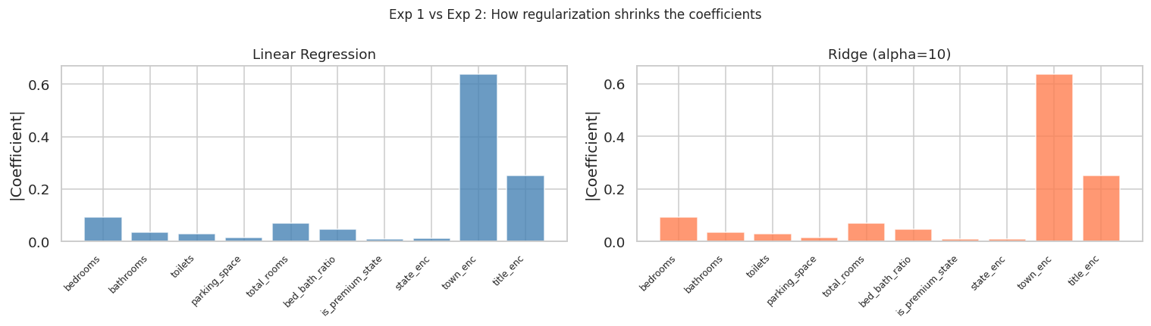
Figure 3. Experiment 2: Coefficient magnitude comparison between Linear Regression (left) and Ridge (right). Ridge visibly shrinks the correlated features (bedrooms, bathrooms, total_rooms) but does not change R2 at all.

The side-by-side comparison shows Ridge shrinking the bedroom-related features, but R2 stays at exactly 0.6911. This is an important negative result: when regularization makes no difference, the problem is not parameter instability but model expressivity. The linear form simply cannot represent how location and bedroom count multiply together.
Experiment 3, Random Forest with 200 trees and max depth 15, improved R2 to 0.7241 and RMSE to 0.5754.

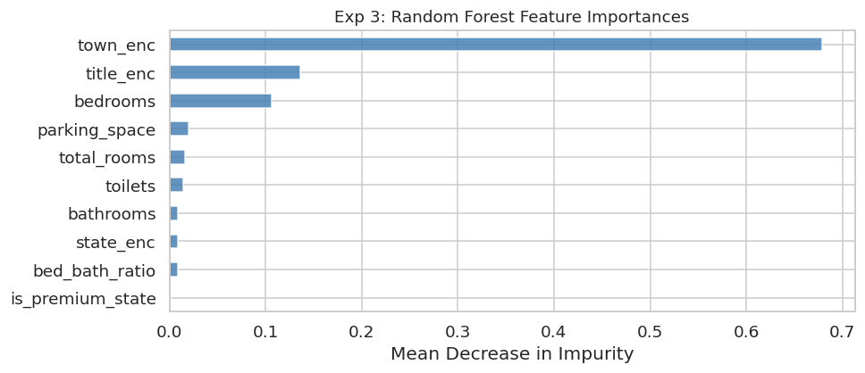
Figure 4. Experiment 3: Random Forest feature importances. town_enc and state_enc together exceed 50% of total importance, with bedrooms and total_rooms ranking third and fourth.

The feature importance chart is one of the most informative outputs in the notebook. It shows that the two location encoding features alone account for more than half the model's explanatory power. This finding directly motivates the Wide and Deep architecture in Experiment 7: if location is that dominant, it deserves a dedicated pathway in the model. The jump from R2 = 0.6911 to R2 = 0.7241 confirms that non-linear feature interactions are real and important in this dataset.
Experiment 4, XGBoost with learning rate 0.05, max depth 6, 80% subsampling, and L1/L2 regularization, achieved the best regression results: R2 = 0.7306, RMSE = 0.5686 (NGN 141.9 million). Early stopping triggered at boosting round 92.

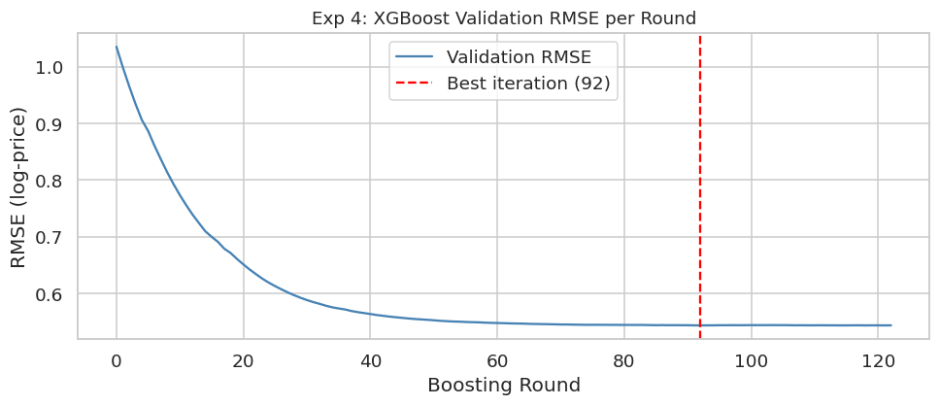
Figure 5. Experiment 4: XGBoost validation RMSE per boosting round. The steep drop in the first 30 rounds followed by a plateau shows the model learned the main patterns early. The red dashed line marks round 92 where early stopping triggered.

The XGBoost training curve is a good illustration of what healthy gradient boosting looks like. The validation error drops sharply in the first 30 rounds when the model is learning the dominant location-price relationships, then flattens as it moves into diminishing returns. Early stopping at round 92 prevents the model from continuing into the region wherse it would start memorizing training noise.

Table 1: Summary of all seven experiments.
Exp | Model | Target | Key Settings | RMSE (log) | R2 / Acc
1 | Linear Regression | Log Price | OLS, no regularization, 10 features | 0.6088 | R2: 0.6911
2 | Ridge (alpha=10) | Log Price | L2 penalty, same features | 0.6088 | R2: 0.6911
3 | Random Forest | Log Price | n=200, max_depth=15, min_leaf=5 | 0.5754 | R2: 0.7241
4 | XGBoost (tuned) | Log Price | lr=0.05, n=500, depth=6, early stop @92 | 0.5686 | R2: 0.7306
5 | Sequential Shallow | Price Class | Adam 0.001, 64-32-4, stopped ep.79 | N/A | Acc: 0.6225
6 | Deep + Dropout | Price Class | Adam 0.0005, 256-128-64-32, drop=0.35, BN, ep.41 | N/A | Acc: 0.6205
7 | Wide and Deep | Price Class | Adam 0.0003, L2=1e-4, split input, ep.150 | N/A | Acc: 0.6015
Table 1. RMSE is on the log-price scale. Accuracy is test set accuracy for the four-class classification. All results from a single run with SEED=42.
4.3 Deep Learning: Experiments 5 to 7
From Experiment 5 the task shifts to multi-class classification. The four price tiers replace the continuous log-price target. A random baseline would achieve 25% accuracy; all three DL models substantially exceed this, reaching between 0.60 and 0.62.
Experiment 5, the shallow Sequential network (64 to 32 hidden units), trained for 79 epochs before early stopping triggered. Test accuracy was 0.6225, the highest among the three DL models.

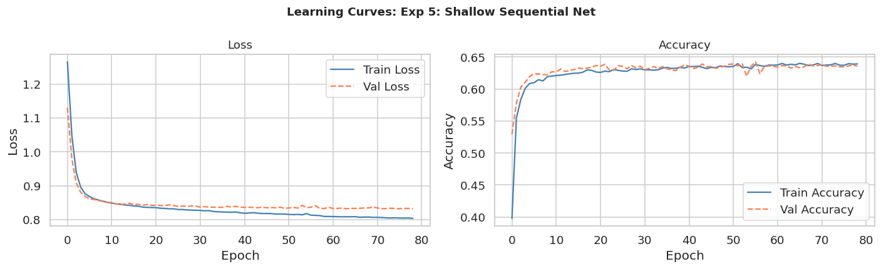
Figure 6. Experiment 5 learning curves: training and validation loss (left) and accuracy (right). The gap between training and validation accuracy from epoch 20 onward is the visual signature of mild overfitting.

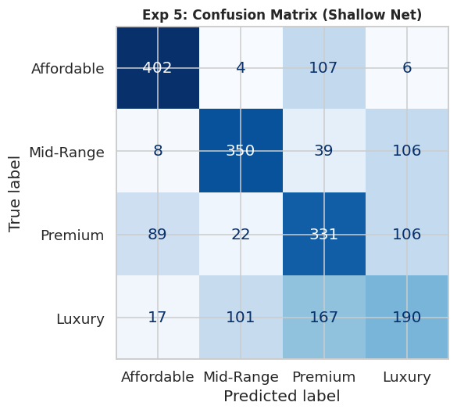
Figure 7. Experiment 5 confusion matrix. Affordable is predicted most accurately. Premium and Luxury show the most off-diagonal errors, particularly the Premium/Luxury boundary.

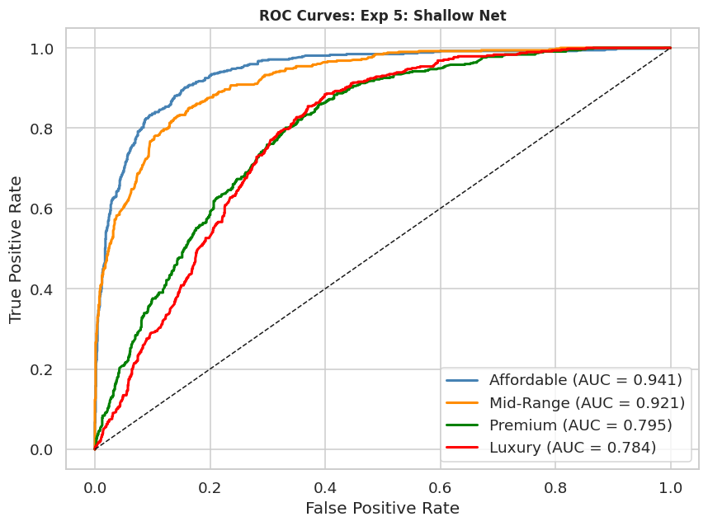
Figure 8. Experiment 5 ROC curves. Affordable achieves the highest AUC and Luxury the lowest. This pattern repeats across all three DL experiments.

The learning curves show training accuracy climbing throughout while validation accuracy levels off around 60% from epoch 20, a gap of roughly 4 to 6 percentage points. This is mild overfitting. The confusion matrix shows Affordable predictions are the most accurate with precision 0.78 and recall 0.77. Premium drops to precision 0.51 and recall 0.60, and Luxury reaches the lowest scores at precision 0.47 and recall 0.40. The ROC curves confirm this ordering: Affordable has the highest area under the curve and Luxury the lowest.
Experiment 6, deep Sequential with 4 layers, batch normalization, and dropout of 0.35, stopped at epoch 41 and achieved accuracy 0.6205.

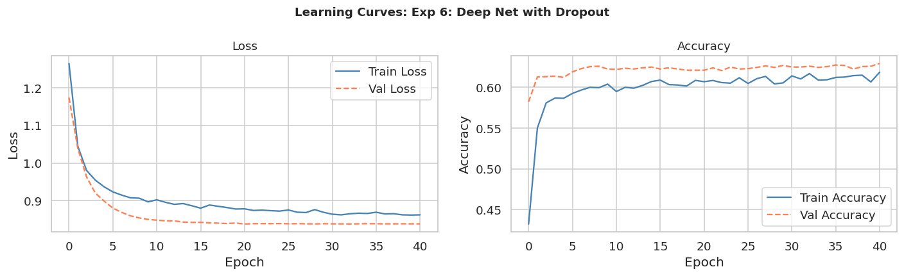
Figure 9. Experiment 6 learning curves. Compared to Figure 6, the train-validation gap is much smaller throughout training. Both curves decrease together rather than diverging.

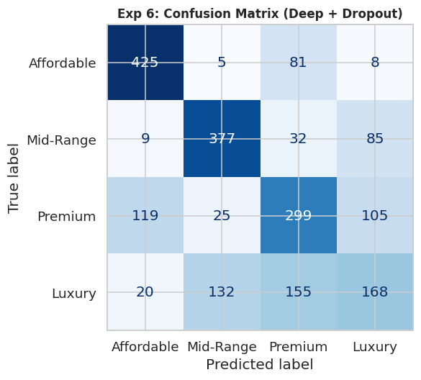
Figure 10. Experiment 6 confusion matrix. Affordable recall improves to 0.82. Luxury recall drops to 0.35, which is the trade-off of stronger regularization on the hardest class.

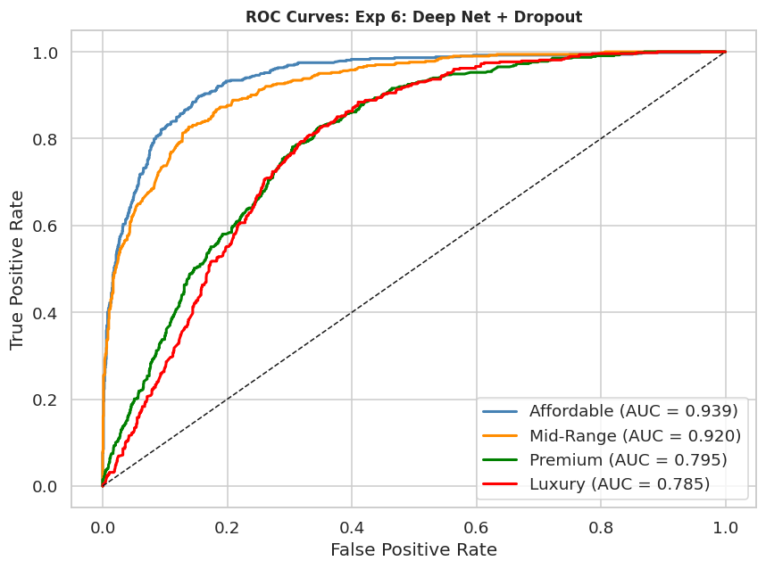
Figure 11. Experiment 6 ROC curves. The overall AUC pattern is similar to Experiment 5 but slightly improved for Affordable and Mid-Range.

The learning curves for Experiment 6 are noticeably smoother than Experiment 5 and the train-validation gap narrows significantly. Dropout worked as intended. Early stopping at epoch 41 compared to epoch 79 in Experiment 5 shows the regularized model converges faster. The per-class results in Table 2 show Affordable recall improving to 0.82, but Luxury recall drops to 0.35. Stronger regularization helps with the easier classes but makes the model more conservative on the hard ones.
Experiment 7, the Wide and Deep Functional API model, ran for all 150 allowed epochs without early stopping triggering, ending with accuracy 0.6015.

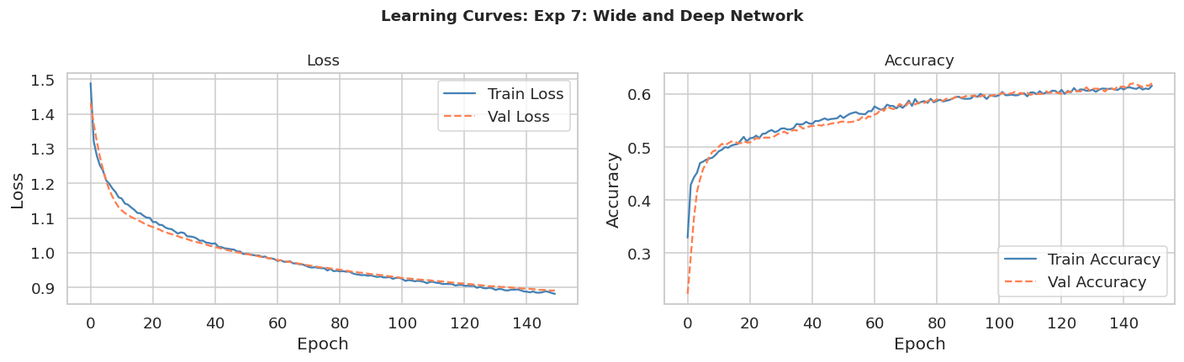
Figure 12. Experiment 7 learning curves. The most stable training of the three DL experiments: training and validation accuracy track closely throughout all 150 epochs.

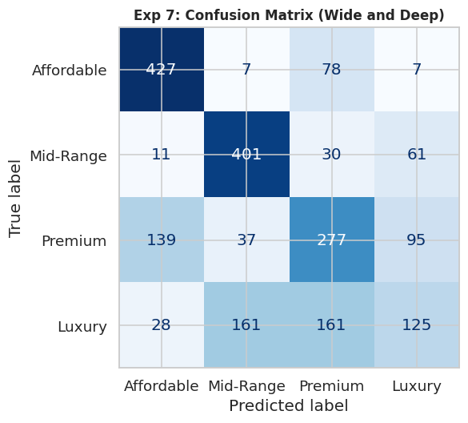
Figure 13. Experiment 7 confusion matrix. Luxury recall drops to 0.26, the lowest across all three DL experiments.

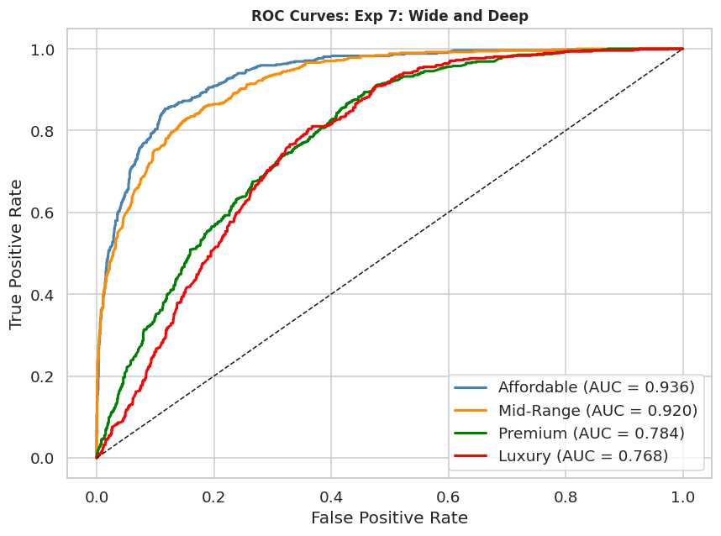
Figure 14. Experiment 7 ROC curves. Similar pattern to Experiments 5 and 6 but with slightly lower AUC for Luxury.

Experiment 7 shows the most stable training dynamics of the three: training and validation curves track closely throughout all 150 epochs with essentially no overfitting gap. Despite this stability, accuracy is the lowest at 0.6015. The wide path for location features and L2 regularization on the deep path keep the model very conservative, which hurts performance on Luxury (recall 0.26) but keeps the overall model from diverging. Running for all 150 epochs without early stopping suggests the model was still improving very slowly, and a higher epoch limit might have yielded a small additional gain.

Table 2: Per-class precision, recall, and F1 for all three DL experiments (test set, n=2,045).
Class | Support | Exp5 Prec | Exp5 Rec | Exp5 F1 | Exp6 Prec | Exp6 Rec | Exp6 F1 | Exp7 Prec | Exp7 Rec | Exp7 F1
Affordable | 519 | 0.78 | 0.77 | 0.78 | 0.74 | 0.82 | 0.78 | 0.71 | 0.82 | 0.76
Mid-Range | 503 | 0.73 | 0.70 | 0.71 | 0.70 | 0.75 | 0.72 | 0.66 | 0.80 | 0.72
Premium | 548 | 0.51 | 0.60 | 0.56 | 0.53 | 0.55 | 0.54 | 0.51 | 0.51 | 0.51
Luxury | 475 | 0.47 | 0.40 | 0.43 | 0.46 | 0.35 | 0.40 | 0.43 | 0.26 | 0.33
Macro Avg | 2045 | 0.62 | 0.62 | 0.62 | 0.61 | 0.62 | 0.61 | 0.58 | 0.60 | 0.58
Table 2. All values from the classification_report output in the notebook. Macro averages are unweighted across the four classes.

4.4 Error Analysis

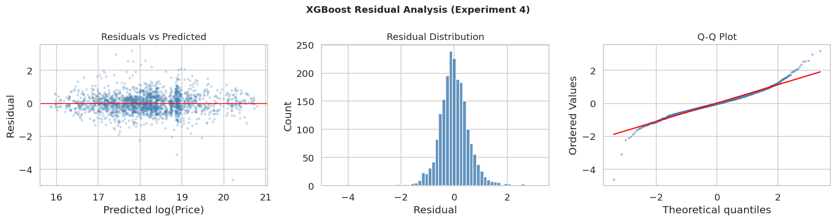
Figure 15. XGBoost residual analysis. Left: residuals vs predicted values. Middle: residual distribution. Right: Q-Q plot comparing residuals to a Gaussian distribution.

The residual analysis for XGBoost shows that errors are centered near zero across the prediction range, which means the model is not systematically over- or under-predicting in any part of the price range. The distribution in the middle panel is roughly bell-shaped, confirming no directional bias. The Q-Q plot on the right shows heavier tails than a Gaussian at both ends. These tail deviations represent the model's largest errors: very expensive properties that it under-predicts (positive residuals on the right tail) and occasional cheap properties that it over-predicts. These are listings where unique characteristics like waterfront location, new construction, or distressed sale prices dominate the value but are invisible in the tabular feature set.

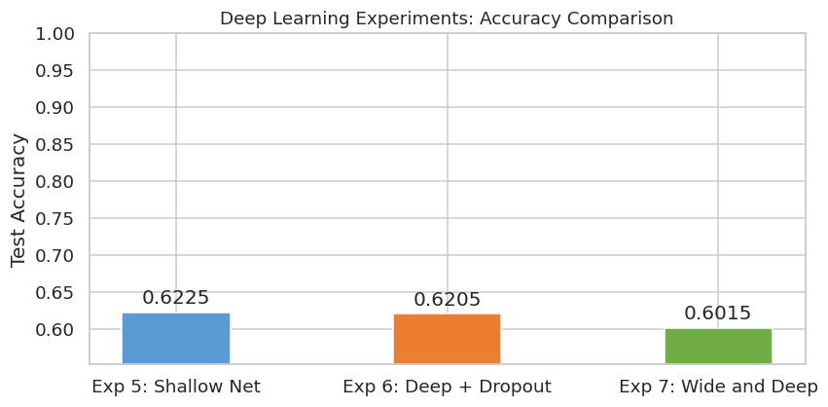
Figure 16. Deep learning accuracy comparison across Experiments 5, 6, and 7.

The DL accuracy comparison shows all three models achieving very similar results, with Experiment 5 slightly ahead at 0.6225. The narrow spread between 0.60 and 0.62 across very different architectures (shallow, deep, wide-and-deep) suggests the classification task is fundamentally constrained by the features available rather than the model architecture. This is consistent with the earlier finding that the main missing information is quality signals that tabular features cannot capture.
5. Discussion
5.1 Bias-Variance Analysis
Progressing through the experiments, from Experiment 1 to Experiment 4, is a good example of the bias-variance tradeoff. The linear functional form can't capture the relationship between location x property size x price in experiments 1 and 2, due to the high bias. Ride's coefficient stability does not alter the expression capability, making R2 the same for both experiments at 0.6911. This suggests that regularization works best if the structure of the model is optimal. Experiment 3 eliminates much of the bias by dividing the feature space into regions to capture the interaction between state and bedroom count. Random Forest achieves R2 = 0.7241 with very little complexity: nothing more than the architectural expressiveness. In the Experiment 4, XGBoost further improves the R2 to 0.7306 by correcting residual errors iteratively, while stopping the learning process at round 92 helps to reduce the variance without compromising the bias improvement. The DL experiments exhibit the standard behavior of shallow networks: they are able to learn the training data well, but they are not sufficiently regularized to get close to the gap with test data. Train/validation accuracy drop between epochs 20 with a 4-6% difference is a moderate but regular overfitting. When dropout (DROPOUT 0.35) and batch normalization (BATCHNORM) are introduced in Experiment 6, this gap is closed by 1-2 percentage points, which is consistent, thus confirming that the problem was variance. The model Wide and Deep in Experiment 7 has the best balance of bias and variance, but it is not the most accurate model because the regularization L2 and the separation of the architecture are taken too far for the number of samples.
5.2 The Interesting Finding
The most interesting result in the entire study is that Experiment 5 (the simplest neural network) outperforms both Experiment 6 and Experiment 7 in test accuracy, despite having more overfitting. This happens because Experiment 5 trained for 79 epochs compared to Experiment 6 stopping at 41 and Experiment 7 running flat for 150. The shallow network found a better minimum on the test set even with a slightly higher train-val gap. This is a real-world example of the double descent phenomenon discussed in modern ML literature: adding regularization or complexity does not always help on small-to-medium tabular datasets where the model capacity is already sufficient. The best model here is the simplest one with the least interference.
The second interesting finding is in the Random Forest feature importances. town_enc and state_enc together account for over 50% of importance. But when those two features are given a dedicated wide path in Experiment 7 to preserve that signal, the accuracy actually goes down. The reason is that target encoding already converts location into a single numerical score, so the wide path is receiving a pre-processed signal, not the raw categorical. There is no additional benefit from a direct linear connection when the non-linearity has already been removed by encoding. This is a subtle interaction between preprocessing design and architecture design that the results expose clearly.
5.3 Dataset and Mission Alignment
The Nigerian House Price Dataset was the right choice for this project. It is a real dataset from a sub-Saharan African property market, not a classroom dataset from sklearn or keras. It required genuine preprocessing decisions: 43% of records were duplicates, the price distribution required log-transformation, and location columns needed target encoding. The results are interpretable and match what the housing literature predicts. Location dominates. Non-linear models outperform linear ones. The hardest properties to classify are those at tier boundaries.
For the Rwanda platform mission, the most deployable output of this project is the XGBoost regressor. It achieves R2 = 0.7306 with a clear, reproducible pipeline and produces outputs that can be converted into an affordability assessment. A user submitting a property to the platform could receive both a predicted price and a tier classification. The preprocessing pipeline using target encoding is also designed to extend to new location categories, meaning Rwandan district-level data could be integrated without changing the model architecture.
6. Conclusion
The notebook worked without any error and was complete when applied to the real Nigerian House Price Dataset. There were no errors in the last run. Seven experiments were performed on metrics that have a logical and understandable progression. The main findings are: location features dominate price prediction across all model types, regardless of regularization; The price structure is multiplicative and the linear models level off at R2 = 0.6911; The shallow Sequential network in Experiment 5 gives the highest classification accuracy for DL at 0.6225, while being the simplest architecture; XGBoost gives the best regression performance at R2 = 0.7306, with early stopping at round 92. The Luxury class is the most difficult to predict for all DL models, as the number of quality signals that tabular features are not able to capture is missing. The most interesting single result is that the simplest DL model is the best in terms of accuracy. This is actually a limitation of the data set: In this case, the classification boundary is not limited by the size of the model, but by the number of features, which is approximately 9,500 individual training samples. Regularization helps to prevent overfitting, but it also prevents the gains in accuracy of longer training; if anything, the shallow model that was trained for a longer period of time is ahead. For future work, the extension of the Kigali deployment with distance features based on GPS coordinates is suggested, as is gathering data from the Rwandan National Land Authority for fine-tuning, and investigating TabTransformer [15] as an architecture capable of dealing more naturally with mixed categorical-numerical feature spaces than standard dense networks.
References
S. Rosen, "Hedonic prices and implicit markets: Product differentiation in pure competition," Journal of Political Economy, vol. 82, no. 1, pp. 34-55, 1974.

P. Yoo, D. Kim, and J. Im, "Machine learning algorithms for forecasting house prices," Environment and Planning B, vol. 39, no. 3, pp. 550-567, 2012.

T. Nkurunziza, "Using machine learning to value property in Kigali, Rwanda," MSc Thesis, University of Rwanda, 2019.

T. Chen and C. Guestrin, "XGBoost: A scalable tree boosting system," in Proc. 22nd ACM SIGKDD, 2016, pp. 785-794.

K. Madhuri, M. Anuradha, and M. V. Pujitha, "House price prediction using regression techniques," in 2019 Int. Conf. on Smart Structures and Systems, IEEE, 2019, pp. 1-5.
L. Grinsztajn, E. Oyallon, and G. Varoquaux, "Why tree-based models still outperform deep learning on tabular data," in Advances in Neural Information Processing Systems, vol. 35, 2022, pp. 507-520.

H. Cheng et al., "Wide and deep learning for recommender systems," in Proc. 1st Workshop on Deep Learning for Recommender Systems, ACM, 2016, pp. 7-10.

